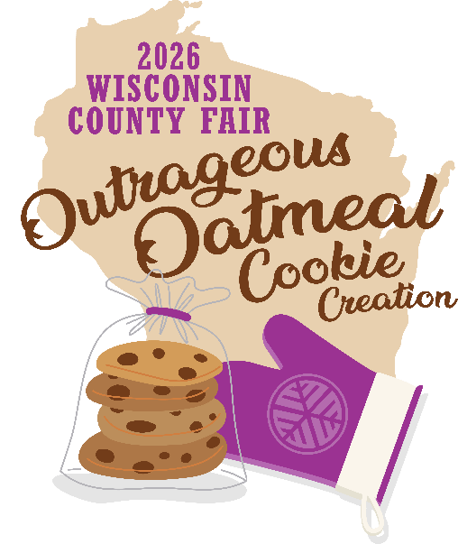
New! 2026 Wisconsin County Fair

Rooted in Tradition…
Outrageous Oatmeal Cookie Creation
Saturday, August 15, 2026
Sponsored by Wisconsin State Fair

Entry Information
Entry deadline: July 14, 2026
Contest drop-off: Saturday, August 15, 2026, 7:30 am – 8:30 am
Contest judging: Saturday, August 15, 2026, 12:00 pm – 1:00 pm
Contest location: Grand Champion Hall
Serving Size: Plate of 9

Tap into your best classic family oatmeal cookie recipe then branch out with amazing add ins to make the most Outrageous Oatmeal Cookie! Wow the judges with the chewiest and delightful
golden oatmeal cookies. The Outrageous Oatmeal Cookie contest will be held on Saturday, August 15, 2026.

Participating County & District Fairs who nominate a Rooted in Tradition…Outrageous Oatmeal Cookie Creation baker to compete will receive two complimentary Wisconsin State Fair admission tickets and one parking pass valid for Saturday, August 15, 2026. See attached nomination form.

Each Rooted in Tradition… Outrageous Oatmeal Cookie Creation baker will receive two complimentary Wisconsin State Fair admission tickets and one parking pass valid for Saturday, August 15, 2026.

Awards provided by Wisconsin State Fair:
1st – $250.00 2nd – $125.00 3rd – $75.00 4th – $35.00

Score Card for 2026 Wisconsin County Fair…Outrageous Oatmeal Cookie Creation
Taste | 40
Ease of Preparation | 35
Creativity | 25
TOTAL | 100

Class #
2026. Outrageous Oatmeal Cookie Creation
… continued on page two

…continued from page one

Please provide two copies of your recipe. The recipe must be typed on 8½" x 11" paper; recipe font size must be 12 point or 14 point. One copy must have your name, and County or District Fair name. The other copy should not have your name or your Fair’s name.
If your recipe is more than one page, use additional sheets of paper (single sided only). See sample below. All recipes must be typed, or the entry will be disqualified.
All recipes must be original to the baker entering them. No prepared mixes may be used.

Required format for Outrageous Oatmeal Cookie Creation recipe

Baker Name __________________________
County or District Fair Name _____________

Ingredients
_______________ _______________
_______________ _______________
_______________ _______________
_______________ _______________

Recipe
__________________________________________________________________________________________________________________________________________________________________________________________________________________________________________________________________________________________________________________________________________________________________________________________________________________
Must be on 8½" x 11" paper

Any questions call 414/777-0580.
Deadline to submit is July 14, 2026.
Email this form to jill.albanese@wistatefair.com

